**Higher Nationals**

Internal verification of assessment decisions – BTEC (RQF)

|  |  |  |  |  |  |  |  |  |  |
| --- | --- | --- | --- | --- | --- | --- | --- | --- | --- |
| **INTERNAL VERIFICATION – ASSESSMENT DECISIONS** | | | | | | | | | |
| **Programme title** | | BTEC HND in Computing | | | | | | | |
| **Assessor** | | Ms Gayani Nisansala | | | **Internal Verifier** | Mr Lakindu Premachandra | | | |
| **Unit(s)** | | Unit 06: Managing a Successful Computing Project | | | | | | | |
| Assignment title | |  | Managing a Project on the environmental impact of digital transformation | | | | | |  |
|  | | | | | |
| **Student’s name** | | Ranudi Gayathmie Kariyapperuma | | | | | | | |
| **List which assessment criteria the Assessor has awarded.** | | **Pass** | | | **Merit** | | **Distinction** | | |
|  | | |  | |  | | |
| **INTERNAL VERIFIER CHECKLIST** | | | | | | | | | |
| **Do the assessment criteria awarded match those shown in the assignment brief?** | | | | Y/N |  | | | | |
| **Is the Pass/Merit/Distinction grade awarded justified by the assessor’s comments on the student work?** | | | | Y/N |  | | | | |
| **Has the work been assessed accurately?** | | | | Y/N |  | | | | |
| **Is the feedback to the student:**  Give details:   * Constructive? * Linked to relevant assessment criteria? * Identifying opportunities for improved performance? * Agreeing actions? | | | | Y/N  Y/N  Y/N    Y/N |  | | | | |
| **Does the assessment decision need amending?** | | | | Y/N |  | | | | |
| **Assessor signature** | | | |  | |  | |  | |
| **Internal Verifier signature** | | | |  | | **Date** | |  | |
| **Programme Leader signature** (if required) | | | |  | | **Date** | |  | |
|  | **Confirm action completed** | | | | |  | | | |
| **Remedial action taken** Give details: |  | | | | |  | | | |
| **Assessor signature** |  | | | | | **Date** | |  | |
| **Internal Verifier signature** |  | | | | | **Date** | |  | |

|  |  |  |  |
| --- | --- | --- | --- |
| **Programme Leader**  **signature** (if required) |  | **Date** |  |

Higher Nationals – Summative Assignment Feedback Form

|  |  |  |  |  |  |  |
| --- | --- | --- | --- | --- | --- | --- |
| **Student Name/ID** | | Ranudi Gayathmie Kariyapperuma / 00104243 | | | | |
| **Unit Title** | | Unit 6 Managing a Successful Computing Project | | | | |
| **Assignment Number** | | 6 | | **Assessor** | Ms.Gayani Nisansala | |
| **Submission Date** | | 25.07.2023 | | **DateReceived1stsub mission** |  | |
| **Re-submission Date** | |  | | **DateReceived2ndsubmissio n** |  | |
|  | | | | | | |
| **Assessor Feedback:**  **LO1.Establish project aims, objectives and time frames based on the chosen theme** | | | | | |  |
|  | **Pass, Merit & Distinction Descripts** | | **P1**  **P2**  **P3** M1          **research, information gathering and data collection to generate knowledge**  **P4**  **M2**  **D1**        **nd communicate appropriate recommendations based on meaningful conclusions**  **findings and/or analysis.**      **P5**  **P6** **M3** **D2**      **gained from conducting the project and its usefulness to support sustainable ce**    **P7**  **M4**  **D3** | | |
| **LO2. Conduct small-scale to support the project** | |
| **Pass, Merit & Distinction Descripts** | |
| **LO3. Present the project a drawn from the evidence** | |
| **Pass, Merit & Distinction Descripts** | |
| **LO4. Reflect on the value organisational performan** | |
| **Pass, Merit & Distinction Descripts** | |
|  | |
|  | | | | | |
| **Grade:** | | **Assessor Signature:** | | | **Date:** | |
| **Resubmission Feedback:** | | | | | | |
| **Grade:** | | **Assessor Signature:** | | | **Date:** | |
| **Internal Verifier’s Comments:** | | | | | | |
| **Signature & Date:** | | | | | | |

* Please note that grade decisions are provisional. They are only confirmed once internal and external moderation has taken place and grades decisions have been agreed at the assessment board.

**Assignment Feedback**

|  |  |  |  |
| --- | --- | --- | --- |
| **Formative Feedback:** | **Assessor to Student** | | |
| **Action Plan** |  | | |
| **Summative feedback** |  | | |
| **Feedback: Student t** | **o Assessor** | | |
| **Assessor signature** |  | **Date** |  |
| **Student signature** |  | **Date** |  |

**Pearson**

**Higher Nationals in**

**Computing**

Unit 6: Managing a Successful Computing Project

### General Guidelines

1. A Cover page or title page – You should always attach a title page to your assignment. Use previous page as your cover sheet and make sure all the details are accurately filled.
2. Attach this brief as the first section of your assignment.
3. All the assignments should be prepared using a word processing software.
4. All the assignments should be printed on A4 sized papers. Use single side printing.
5. Allow 1” for top, bottom, right margins and 1.25” for the left margin of each page.

### Word Processing Rules

1. The font size should be **12** point and should be in the style of **Time New Roman**.
2. **Use 1.5 line spacing**. Left justify all paragraphs.
3. Ensure that all the headings are consistent in terms of the font size and font style.
4. Use **footer function in the word processor to insert Your Name, Subject, Assignment No, and Page Number on each pag**e. This is useful if individual sheets become detached for any reason.
5. Use word processing application spell check and grammar check function to help editing your assignment.

**Important Points:**

1. It is strictly prohibited to use textboxes to add texts in the assignments, except for the compulsory information.

eg: Figures, tables of comparison etc. Adding text boxes in the body except for the before mentioned compulsory information will result in rejection of your work.

1. Carefully check the hand in date and the instructions given in the assignment. Late submissions will not be accepted.
2. Ensure that you give yourself enough time to complete the assignment by the due date.
3. Excuses of any nature will not be accepted for failure to hand in the work on time.
4. You must take responsibility for managing your own time effectively.
5. If you are unable to hand in your assignment on time and have valid reasons such as illness, you may apply (in writing) for an extension.
6. Failure to achieve at least PASS criteria will result in a REFERRAL grade.
7. Non-submission of work without valid reasons will lead to an automatic REFERRAL. You will then be asked to complete an alternative assignment.
8. If you use other people’s work or ideas in your assignment, reference them properly using HARVARD referencing system to avoid plagiarism. You have to provide both in-text citation and a reference list.
9. If you are proven to be guilty of plagiarism or any academic misconduct, your grade could be reduced to A REFERRAL or at worst you could be expelled from the course

### Student Declaration

I hereby, declare that I know what plagiarism entails, namely to use another’s work and to present it as my own without attributing the sources in the correct way. I further understand what it means to copy another’s work.

1. I know that plagiarism is a punishable offence because it constitutes theft.
2. I understand the plagiarism and copying policy of the Pearson UK.
3. I know what the consequences will be if I plagiaries or copy another’s work in any of the assignments for this program.
4. I declare therefore that all work presented by me for every aspects of my program, will be my own, and where I have made use of another’s work, I will attribute the source in the correct way.
5. I acknowledge that the attachment of this document signed or not, constitutes a binding agreement between myself and Pearson UK.
6. I understand that my assignment will not be considered as submitted if this document is not attached to the attached.

### ranudigk@gmail.com

**Student’s Signature: Date: 25.07.2023**

**(*Provide E-mail ID*) (*Provide Submission Date*)**

### Higher National Diploma in Computing

Assignment Brief

|  |  |
| --- | --- |
| Student Name /ID Number | Ranudi Gayathmie Kariyapperuma / 00104243 |
| **Unit Number and Title** | Unit 6: Managing a Successful Computing Project |
| Academic Year | 2021/20222018 |
| Unit Tutor | Ms.Gayani Nisansala |
| **Assignment Title** | Managing a Project on the environmental impact of digital transformation. |
| Issue Date | 01.05.2023 |
| Submission Date | 25.07.2023 |
| IV Name & Date |  |
| **Submission Format:** | |
| The submission should be in the form of an individual report written in a concise, formal business style using single spacing (refer to the assignment guidelines for more details). You are required to make use of headings, paragraphs, and subsections as appropriate, and all work must be supported with research and referenced using Harvard referencing system. Please provide in-text citation and a list of references using Harvard referencing system.  Please note that this is an individual assessment and your report should include evidences to that you have conducted a research to collect relevant data individually. | |

|  |
| --- |
| **Unit Learning Outcomes:** |
| **LO1** Establish project aims, objectives and timeframes based on the chosen theme.    **LO2** Conduct small-scale research, information gathering and data collection to generate knowledge to support the project.    **LO3** Present the project and communicate appropriate recommendations based on meaningful conclusions drawn from the evidence findings and/or analysis.    **LO4** Reflect on the value gained from conducting the project and its usefulness to support sustainable organizational performance. |

**Assignment Brief and Guidance:**

Research Theme: The environmental impact of digital transformation Research

Topic: The impact of digital endpoint devices and ways to reduce environmental damage.

“The amount of data created and stored globally is expected to reach 175 Zettabytes by 2025, a six-fold increase from 2018. This will demand additional hardware and power consumption, which; in turn, will increase the environmental impact of the digital sector and there is already increasing attention on the environmental footprint of ICT equipment and services as they become more widespread in all aspects of human life. It is the responsibility of everyone to take action in addressing the challenges of climate change, as professionals we must also seek ways that the digital sector can play its part. While digital technologies are one of the sectors that have achieved greater efficiency; achieving about 100 times more computation power from the same amount of energy per decade, it remains unsustainable. The sector must continue to seek ways in which it can continue to support and drive innovation while addressing the global climate emergency for a greener and fairer future.”.(Pearson, 2022)You are expected to carry out small-scale research in order to explore the impact of digital endpoint devices and ways to reduce environmental damage, from the standpoint of a computing professional. The research that you carry out can be based on an organization that you have access to gather sufficient information to investigate the environmental impact of digital transformation.

The report should include,

* A comprehensive project management plan
* Evaluation of data collection methods and data analysis tools and/or techniques should be provided
* Appropriate recommendations should be provided
* Reflect on the value gained from conducting the project and its usefulness to support sustainable organisational performance

]

#### TASK – 01

1.1 Definethe scope of the project and devise aims and objectives of the project that you are going to carry out. You also should include a brief introduction to the selected company, digital endpoint devices they use and the impact of them to the environment, explanation to the project and other relevant information about the research.

1.2 **Produce** a comprehensive project plan including the following.

* Cost, scope, time, quality, communication, risk, and resources management plan
* Comprehensive Work Breakdown Structure (WBS) with clearly defined activities and milestones
* Gannt chart to illustrate project schedule with realistic time allocated for each activity and clearly defined deadlines for milestones.

#### TASK – 02

Carry out a research to investigate the impact of digital endpoint devices and the ways to reduce environmental damage’ by applying appropriate qualitative and quantitative research methodologies and critically evaluate the reliability, accuracy and the appropriateness of the research methods applied. your answer also should include a critical evaluation of the project management process and a justification to the selected research methodologies.

#### TASK – 03

3.1 Analyse research data collected to support your research project using appropriate tools, techniques and critically evaluate how selected tools, techniques uphold authenticity and the accuracy of the data collected.

3.2 Draw valid conclusions and recommendations from the research data analysed and communicate your recommendations to the top management of the organization through an action plan. The action plan should include a justification to the recommendations suggested.

#### TASK – 04

Reflect on the objectives of the project and your own learning experience gained through following a quality research and the project management process. Critically evaluate the ways in which the research project carried out supports the organization to sustain its performance while reducing environmental damage and how the project specifically supported you to improve your own learning and performance .

##### ACKKNOWLEDGEMENT

At last author would like to share the experience while doing the project. Author learns many new things about the projects. The best thing which author can share is that author developed more interest in this subject. This Module gave an interest to the author to find more information about it. .

A very special thanks to Miss Gayani who teach us this subject and Author thanks for who helped author to do this kind of project. Thank you!

Regards,

The author,

Ranudi Kariyapperuma.

**TABLE OF CONTENT**

Services of Dialog Company 19

Vision of Dialog Company 19

Mission of Dialog Company 20

Introduction of Digital Transformation 20

Areas that using digital transformation in Dialog Company 21

Explanation of Some of the areas that how it is use in digital transformation at Dialog Company 23

Challenges of Digital Transformation 26

The Challenges that Dialog Company had when using digital transformation. 28

Significant of Studies 29

Aims of Dialog Company Using Digital Transformation 29

The Purpose of This Research 32

Objectives 33

Awareness of Digital Transformation 33

The Environment impact of Digital Transformation 35

Reducing The Impact of Digital Transformation 37

Project Management 39

Key stages of Project Management 40

Advantages of using Project Management 40

Disadvantages of using Project Management 41

Importance of Project Management 42

Information about Cost ,Scope ,time, quality ,communication , risk and resources management plans 44

Cost Management Plan 44

Scope Management Plan 45

Time Management Plan 46

Quality Management Plan 47

Communication Management Plan 48

Risk Management Plan 49

Resources Management Plan 50

Scope 52

Work Breakdown 53

Reasons of using work breakdown Structure 54

Work BreakDown Structure of Dialog Company Research 55

Gantt Chart of The Dialog Company Research 55

The Ethices 56

Ethics that use for Digital Transformation 57

The Reasons using Ethics. 58

Advantages of Using Ethics 59

Analyzing data of digital transformation in Dialog Company 61

Introduction 61

Demographical data analysis 61

Gender Distribution 62

Age Group 62

Civil Status 63

whether employees read the above survey description and knew or did not know what this research was about. 63

Interference Analysis 64

Descriptive Statistics 65

Reliability Testing of Data set 66

Nature of Dependent Variable 66

Research 68

Qualitative research Methods 68

Quantitative Methods: 72

Project Management plan for the Project 73

The Way use the Project management plan to the project 75

Gantt Chart of the Assignment 77

References 77

**TABLE OF FIGURES**

Figure 1 : Dialog Company Logo 18

Figure 2 : Digital Transformation 21

Figure 3 : Work Breakdown Structure Of Dialog Company 55

Figure 4 : Gantt Chart Of The Dialog Company 55

Figure 5 : Gender Distribution 62

Figure 6 : Age Group 62

Figure 7 : Civil Status 63

Figure 8 : Whether Employees Read The Above Survey Description And Knew Or Did Not Know What This Research Was About. 63

Figure 9 : Interference Analysis 64

Figure 10 : Descriptive Statistics 65

Figure 11 : Reliability Statistics 66

Figure 12 : Normality Distribution Statistics Calculated By Spss For The Dependent Variable Of Environmental Sustainability 67

Figure 13 : Author Developed Suvey 69

Figure 14 : Author Developed Survey 70

Figure 15 : Author Developed Survey 71

List Of Tables

Table 1 : The Environment impact of Digital Transformation 36

Table 2 : Project Management Plan 74

**Description about Dialog Company**

Providing a wide variety of mobile, fixed-line, and digital services to both residential and commercial users, Dialog Axiata PLC is one of Sri Lanka's top telecom service providers. The Sri Lankan telecoms sector has been significantly shaped by the 1993-founded corporation, which has also been at the forefront of technological advancement and superior customer service.

Dialog Axiata has made a name for itself in the country's telecommunications market by placing a heavy emphasis on providing cutting-edge solutions and services. The business has established a sizable network backbone, enabling it to offer dependable and superior communication services throughout Sri Lanka. Voice, data, and messaging are all included in its mobile services, which serve a wide range of steadily expanding clientele.



Figure 1 : Dialog Company Logo

Dialog Axiata has expanded into the world of digital services, offering cutting-edge options like mobile payment services, digital entertainment, and other value-added services to improve the overall digital experience for its clients. The business has established a reputation for excellence and dependability in the telecoms industry thanks to its dedication to technological innovation and client satisfaction.

As part of its corporate social responsibility efforts, Dialog Axiata engages in several activities outside of its main business operations. These activities help the company to support local communities by focusing on initiatives that promote environmental sustainability, healthcare, and education.

As a well-known telecommunications company in Sri Lanka, Dialog Axiata is committed to offering cutting-edge and easily accessible telecommunications products, helping the nation's digital environment flourish and develop in general.

# Services of Dialog Company

1. Mobile Services

providing phone, data, and messaging services for a sizable customer base in Sri Lanka using mobile devices.

1. Fixed Line Services

offering home and commercial customers fixed-line telecommunications services, such as voice, internet, and other related services.

1. Digital Services

supplying customers with a range of digital services, such as mobile payment options, digital entertainment, and other value-added services.

1. Enterprise Solutions

offering a variety of telecoms and digital solutions, such as connectivity, cloud services, and data solutions, that are suited to the requirements of organizations and enterprises.

1. Network Infrastructure

creating and maintaining a solid network infrastructure to offer dependable and effective telecommunications services in Sri Lanka.

# Vision of Dialog Company

“To be the undisputed leader in the provision of multi-sensory connectivity resulting always, in the empowerment and enrichment of Sri Lankan lives and enterprises.” (Anon., n.d.)

# Mission of Dialog Company

“To lead in the provision of technology enabled connectivity touching multiple human senses and faculties, through committed adherence to customer-driven, ethical, responsive and flexible business processes, and through the delivery of quality service and leading edge technology unparalleled by any other, spurred by an empowered set of dedicated individuals who are driven by an irrepressible desire to work as one towards a common goal in the truest sense of team spirit.” (Anon., n.d.)

# Introduction of Digital Transformation

The term "digital transformation" describes the rapid and extensive transformation of corporate operations, procedures, skills, and models to take full advantage of the opportunities offered by digital technologies. It involves fundamentally altering how organizations function and provide value to customers, not just integrating digital technology into various elements of a firm. Reimagining an organization's use of technology, people, and processes in order to significantly alter company performance is known as digital transformation.

The main objectives of digital transformation are to improve customer experiences, increase operational effectiveness, and develop new business models and revenue sources. Organizations can optimize their operations, streamline procedures, and gain a competitive edge in an increasingly digital world by utilizing emerging technologies like artificial intelligence, cloud computing, big data analytics, the Internet of Things (IoT), and others.

To promote a digital-first mindset, successful digital transformation programs frequently include a thorough redesign of current company strategies, organizational structures, and cultural norms. This entails encouraging an innovative, agile, and adaptable culture and equipping staff to effectively accept and use digital tools.

Businesses that successfully handle the challenges of digital transformation can experience gains in efficiency, decision-making, customer engagement, and the capacity to seize untapped market opportunities. However, the process can be difficult and calls for thorough preparation, wise expenditures, and a readiness to change with the rapidly changing technology environment.

Figure 2 : Digital Transformation

## Areas that using digital transformation in Dialog Company

* Customer experience

includes using digital tools and platforms to improve customer connections and provide individualized experiences via social media involvement, chatbots, and customized services.

* Operations and Efficiency

Optimizing production, cutting costs, and raising overall efficiency can be achieved by streamlining internal operations using automation, AI-driven analytics, and IoT devices.

* Data analytics

The process of using big data and analytics to make predictions and decisions by gaining insights into consumer behavior, market trends, and operational effectiveness.

* Supply Chain Management

Supply chain tracking and optimization through the use of digital technologies that increase transparency, lower errors, and improve logistics as a whole.

* Employee engagement

The process of using digital tools and platforms to improve employee training, communication, and teamwork in order to increase output and job satisfaction.

* Product Development

The utilization of digital technology to promote creativity, swiftly develop and evaluate novel goods or services, and promptly adjust to evolving market needs is known as innovation and product development.

* Cybersecurity

Putting strong digital security measures in place to guard against attacks and breaches involving sensitive data, systems, and networks.

* Sales and Marketing

Using digital marketing techniques to efficiently reach and engage customers, such as social media, SEO, content marketing, and targeted advertising.

* Cloud computing

Using cloud-based solutions to manage IT infrastructure and services more affordably, flexibly, and scalable.

* Regulatory compliance

Refers to the use of digital technologies to automate reporting and compliance processes, as well as to assure adherence to industry norms and laws.

## Explanation of Some of the areas that how it is use in digital transformation at Dialog Company

1. **Customer experience**

* Data-Driven Personalization

Tailor interactions based on client information. Use AI-driven systems to evaluate consumer behavior and preferences and provide personalized communications, product recommendations, and services.

* Chatbots and Self-Service Portals

Create chatbots powered by AI and self-service portals that are easy to use. These tools offer round-the-clock assistance to users by helping them access information, solve problems, or make transactions without the need for human assistance.

* Real-time Support

For prompt customer support, use instant messaging apps or live chat options. Leverage AI to manage common questions and forward complicated problems to human representatives for prompt and effective response.

* Mobile Optimization

Give special attention to mobile-first tactics and make Dialog's website and services mobile-friendly. In order to provide clients with even more functionality and convenience, think about creating a specific mobile app.

* Analytics for Customer Insights

Make use of cutting-edge analytics to learn about the preferences, behavior, and problems of your customers. Utilize these insights to improve offerings and products/services in order to better satisfy customers.

* Proactive Communication

Anticipate client requirements and preferences by utilizing predictive analytics. Before they ever state a need, proactively reach out to customers with pertinent offerings or solutions.

* Customer Feedback and Engagement

Use digital platforms to gather customer feedback, keep an eye on social media to see how customers are feeling, and communicate with them through surveys or other interactive communication methods.

* Continuous Improvement

To continuously enhance the overall customer experience, evaluate the customer journey on a regular basis, pinpoint pain points, and iterate on digital solutions.

* Security and Trust

To safeguard client data and foster trust, make sure that strong cybersecurity measures are in place. Talk openly and honestly.

1. **Operations and Efficiency**

* Process automation

Refers to the use of automation technologies, such as AI-driven workflows and robotic process automation (RPA), to automate repetitive operations and procedures. Human error may decrease and efficiency may rise as a result.

* IoT Integration

Using sensors and Internet of Things (IoT) devices to collect data and insights in real-time. Predictive maintenance, inventory management optimization, and general operational efficiency can all be enhanced with the utilization of this data.

* Cloud-Based Solutions

Moving computer resources, storage, and collaboration to cloud-based platforms. This enables remote access to vital data and applications while offering scalability, flexibility, and cost-effectiveness.

* Employee empowerment

the process of giving staff members access to digital platforms and technologies that improve productivity, teamwork, and communication. This covers e-learning platforms, virtual collaboration tools, and project management software.

1. **Data Analytics**

* Business intelligence (BI)

The process of using BI technologies to gather, examine, and present data from several sources inside the organization. This offers perceptions into consumer behavior, market trends, company performance, and operational effectiveness.

* Predictive analytics

The process of forecasting future patterns and results using both historical and current data. Proactive decision-making can be aided by predictive models' ability to predict consumer preferences, market demands, and potential threats.

* Customer Segmantation

Segmenting the customer base by analyzing customer data is known as customer segmentation. This makes it possible to implement customized product offerings, individualized marketing campaigns, and focused outreach to various clientele segments.

* Operational optimization

The process of using analytics to optimize workflows and internal operations. This entails locating bottlenecks, allocating resources as efficiently as possible, and raising overall operational effectiveness.

* Real-time Monitoring

Tracking important indicators and KPIs in real-time by using analytics. This makes it possible to react quickly to shifting concerns or trends, which promotes flexible decision-making.

* Market analysis

The process of using analytics to comprehend customer sentiment, competitive analysis, and market trends. Marketing plans and efforts for new product development can be guided by this information.

* Risk Management

Utilizing predictive analytics to identify and reduce hazards is known as risk management. This entails determining possible risks in supply chains, operations, or market swings and creating plans to effectively manage them.

## Challenges of Digital Transformation

In the word industries have tons of challenges to face and also to know. So in digital transformation also have challenges to face. So the challenges are ,

* Legacy Systems Integration

It might be difficult to integrate new digital solutions with pre-existing legacy systems. Significant hurdles include data migration, compatibility issues, and the requirement for seamless integration.

* Cultural Resistance

Attempts to implement digital transformation may be hampered by internal organization resistance to change. It may be difficult for staff members to accept new procedures or technology, thus change management techniques must be used carefully.

* Data management

Managing and utilizing massive amounts of data presents difficulties for data security, quality, and regulatory compliance. It's crucial to manage data privacy and make sure data is used ethically.

* Talent and capabilities Gap

It might be difficult to find and keep talent who possesses the requisite digital capabilities. It might be challenging to find people who are knowledgeable about cutting-edge technology like cybersecurity, AI, and data analytics.

* Cybersecurity Risks

As society becomes more digitalized, cybersecurity risks grow. Strong security measures and ongoing attention to detail are necessary to prevent cyberattacks on digital assets, systems, and sensitive data.

* Costs and ROI Uncertainty

Digital transformation projects frequently need a large initial outlay of funds. It might be difficult to determine and guarantee a clear return on investment (ROI), particularly in the near run.

* Strategic Alignment

It's critical to match digital initiatives with overarching company objectives and strategy. It might be difficult to make sure that transformation initiatives support the goals and vision of the organization.

* Selecting the Correct suppliers and Technology Partners for Digital Solutions

Selecting the appropriate suppliers and technology partners can be difficult. It's crucial to assess choices, negotiate contracts, and preserve fruitful collaborations.

* Regulatory Compliance

It can be difficult to modify digital efforts to conform to changing rules and regulations, particularly in sectors with strict compliance mandates.

* Customer Experience and Adoption

The success of the transformation process depends on guaranteeing a seamless transfer for customers to new digital platforms or services and preserving a high-quality user experience.

## The Challenges that Dialog Company had when using digital transformation.

* Infrastructure Restriction

In some places, putting advanced digital solutions into practice may be difficult due to a lack of infrastructure, particularly internet access and technology infrastructure.

* Skills Gap

There may not be as many qualified experts available in developing technologies. Employers may have trouble finding new hires or upskilling current staff members with the necessary digital skill sets.

* Regulatory Environment

It may be difficult to adjust to and abide by changing regulatory frameworks and rules pertaining to cybersecurity, data protection, and technological implementations.

* Technology Access

Although access to technology may be greater in metropolitan regions, due to infrastructure constraints, adopting digital solutions may be more difficult in rural or isolated areas.

* Digital Literacy

It may be difficult to promote and improve digital literacy in the broader public. It may be necessary to educate some population segments on the proper use of digital tools and platforms.

* Cybersecurity Issues

As digital solutions are used more frequently, there is a greater chance that cybersecurity attacks may occur. It may be difficult to ensure strong cybersecurity safeguards, particularly for smaller companies with fewer budgets.

* Cost

Sophisticated digital technology may be difficult for smaller companies or startups to use due to budgetary constraints.

# Significant of Studies

## Aims of Dialog Company Using Digital Transformation

* Enhanced Customer Experience

Personalized services, better consumer interactions, and seamless omnichannel experiences are the goals of digital transformation. This is consistent with Dialog's objective of becoming a customer-focused company, guaranteeing contentment and allegiance. To enhance customer experiences employees do these things such as ,

* Confirm that all digital touchpoints—including websites, mobile apps, social media, and in-store interactions—offer consistent experiences.
* Make use of AI-driven tools and data analytics to comprehend consumer behavior and preferences. This boosts engagement by enabling individualized advice, customized services, and focused messaging.
* Create AI chatbots and self-service portals that are easy to use. These technologies promote accessibility and convenience by enabling users to look for information, solve problems, and make transactions on their own.
* Use instant messaging and live chat tools to provide quick customer support.
* Platforms and services should be customized for smooth mobile interactions. Customers that are always on the go can benefit from an optimized mobile website and a dedicated mobile app.
* Utilize digital platforms to collect and evaluate client feedback. To enable iterative improvements, leverage data analytics, social media listening, and online surveys to gain insight into customer sentiment.
* To foresee client demands, use machine learning and predictive analytics.
* Operational Efficiency

The goal of digital transformation is to lower operating costs, optimize resource allocation, and streamline internal operations. This is consistent with Dialog's objective of preserving a competitive advantage through effective operations.

Dialog Company uses cutting-edge technical solutions to optimize business operations by embracing digital transformation. The organization wants to improve productivity, lower operating expenses, and streamline workflows by implementing digital tools and methods. Dialog increases the effectiveness of internal processes, resource allocation, and decision-making through process automation, Internet of Things integration, and data-driven insights. By adopting digital solutions, the business can save manual labor, boost flexibility, and promote ongoing development across several divisions, all of which contribute to improved operational efficiency and the preservation of a competitive advantage in the marketplace.

* Adaptability and Innovation

Dialog's ability to quickly prototype new services, drive product development, and adjust to shifting market demands is made possible by digital transformation, which supports Dialog's capacity to remain innovative.

Dialog Company views digital transformation as a driver of innovation and adaptation. Utilizing state-of-the-art technologies and cultivating an innovative culture, the organization aims to propel progressive endeavors and quickly adjust to market shifts. Dialog creates an environment that is conducive to ongoing innovation by utilizing agile approaches, fast prototyping, and adopting cutting-edge technologies like AI, IoT, and data analytics. With this strategy, the organization can investigate new business models, promptly adapt to changing client wants, and proactively develop ground-breaking solutions that help it stay ahead of the always changing market.

* Market Leadership

By embracing digital transformation, Dialog is able to take the lead in the market by providing innovative digital services and solutions that meet changing consumer demands and market trends.

uses the digital transformation as a pillar to achieve market leadership. Utilizing cutting-edge digital technology and insights gleaned from data, the organization hopes to lead the market and establish industry standards. Dialog increases brand awareness and engagement by utilizing creative digital tactics, tailored consumer experiences, and a strong online presence across several platforms. By embracing digital transformation, the business can foresee market trends, respond quickly to shifting consumer needs, and develop innovative solutions, establishing Dialog as a leader in the industry recognized for its technological prowess, creativity, and customer-centricity.

* Sustainable Growth

Dialog wants to attain sustainable growth through digital transformation. To do this, the company is investing in technologies that support social and environmental responsibility and help create a more equitable and greener future.

accepts digital transformation for sustainable development as well as business progress. The organization strives for sustainable growth through the integration of environmentally friendly technologies, optimization of energy usage, and adoption of environmentally responsible practices. Dialog finds ways to improve operational effectiveness and reduce its environmental impact by using data-driven tactics. The organization makes sure that technological advancements support both business expansion and environmental sustainability by utilizing renewable energy sources, lowering e-waste, and promoting eco-friendly practices across all of its digital initiatives. This helps to ensure a greener future while spurring ongoing growth.

## The Purpose of This Research

is to investigate how digital endpoints in a business or organizational context affect the environment. It is important to comprehend the growing environmental impact that digital technologies—particularly endpoint devices such as computers, smartphones, tablets, and other connected gadgets—cause. This study intends to offer solutions and suggestions to lessen this impact by analyzing the present condition of these gadgets, their usage habits, and the ensuing environmental effects.

Some main purposes are ,

* Comprehending Impact

To thoroughly look into and comprehend how the usage, maintenance, and disposal of digital endpoint devices affect the environmental impact of the company. This entails evaluating the gadgets' contributions to trash production, carbon emissions, resource depletion, and energy usage.

* Finding Improvement Opportunities

To identify particular facets of the company's digital ecosystem that materially harm the environment. In order to lessen the negative impact, this identification is crucial for focused actions and strategic planning.

* Creating Mitigation Strategies

To create workable suggestions and plans to lessen the harm that digital gadgets do to the environment. Using energy-efficient gadgets, starting recycling initiatives, maximizing device utilization, and supporting environmentally friendly purchasing methods are a few examples of these tactics.

* Encouraging Sustainable Practices

To push for and encourage an environmentally conscious culture inside the company. The objective is to promote environmentally responsible activities and deliberate decision-making among stakeholders by showcasing the research findings and recommendations.

* Adding to Knowledge Base

To increase the amount of information already available about the environmental effects of digital transformation in organizational settings by adding empirical data and insightful analysis. This study's impact can extend beyond its local focus by acting as a benchmark for comparable projects in other organizations.

* Professional Responsibilities

The research highlights the ethical need for computing experts to address the environmental effects of technology. It emphasizes how crucial it is to match technology development with environmentally friendly behavior in order to create a more sustainable future.

# Objectives

## Awareness of Digital Transformation

Understanding and admitting the widespread effects and effects of technological incorporation in a variety of areas of society, the economy, and personal life is referred to as awareness of digital transformation.

1. Understanding Technological Influence

Educating people and businesses about digital transformation enables them to better understand how technology is changing society norms, work processes, daily life, and communication.

1. Adapting to Change

Awareness promotes adaptability, allowing people and companies to proactively respond to changing market needs and technological advancements.

1. Economic and Industrial Shifts

Businesses must comprehend digital transformation to remain competitive in quickly changing markets and to enable the adoption of cutting-edge technologies and new business models.

1. Improving Prospects

Raising awareness generates chances for skill development and produces a workforce that can take advantage of and benefit from technology breakthroughs.

1. Ethical and Social Issues

Understanding the effects of digital transformation increases consciousness regarding moral conundrums, including data privacy, security, and AI ethics, as well as their effects on society.

1. Formulation and Regulation of Policies

Policy Guidance It helps legislators create laws that strike a balance between innovation and societal demands, guaranteeing the moral and responsible use of technology.

1. Inclusive Development: Digital Inclusion

This guarantees that attempts are made to close the digital gap, enabling technology to be useful and accessible to all facets of society.

1. Holistic Perspective

Comprehensive Decision-Making: People and organizations with awareness are able to make well-informed judgments about technological investments by taking the environment and society's long-term effects into account.

1. Environmental Implications

Developing and implementing eco-friendly technology and practices is prompted by an understanding of how the digital transformation will affect the environment.

1. Innovation and Collaboration

Increased awareness encourages cooperation between business, academia, and governmental organizations, resulting in innovation that meets societal demands while taking ethical and environmental factors into account.

## The Environment impact of Digital Transformation

Analyzing the ways in which digital transformation affects the environment requires evaluating a number of variables that are impacted by technological developments.

|  |  |  |  |
| --- | --- | --- | --- |
| **Main Reasons** | | **Co-reasons** | **Description** |
| Energy Consumption | | Data Centers | Determine how much energy is used by these locations, which house digital services. Examine their power usage effectiveness (PUE) analysis and investigate the use of renewable energy. |
| Device Power Consumption | Evaluate how much energy is used by the computers, cellphones, and Internet of Things devices that are a part of the digital ecosystem |
| Electronic Waste | Analysis of the Life Cycle | | Electronic Waste Examine the manufacturing, use, and disposal stages of a digital device's lifecycle. Examine the amount of electronic waste produced and the methods used for disposal. |
| Recycling and Electronic Equipment Disposal Practices | | Evaluate the company's efforts in recycling and electronic equipment disposal. |
| Carbon Footprint | Emissions Analysis | | Determine the carbon emissions connected to digital infrastructure manufacturing, energy use, and transportation. |
| Impacts of Remote Work | | Assess the environmental effects of working remotely, taking into account less energy used in offices |
| Depletion of Resources | Use of Raw Materials | | Examine the extraction of materials for the production of electronic gadgets. Evaluate the effect on water, minerals, and rare earth metals, among other natural resources. |
| Initiatives for the Circular Economy | | Examine how the company is attempting to integrate circular economy principles into the supply chain for technology |
| Cloud Computing | Cloud Service Impact | | Consider server infrastructure, data transmission, and virtualization technologies when assessing the environmental effects of cloud services. |
| Comparative Analysis | .  Benchmarking and Comparative Analysis | | To find more environmentally friendly options or methods, compare the effects of various technologies and gadgets on the. |
| Externalities and indirect impact | .    Indirect Effects | | Consider unintended consequences such as modifications in consumer behavior brought on by the digital revolution, which may have an indirect impact on trash production or patterns of energy consumption |
| Stakeholder Engagement | Employee Surveys | | Use surveys to learn about the habits and perspectives of employees with relation to the use of devices, their disposal, and environmental concerns. |

Table 1 : The Environment impact of Digital Transformation

## Reducing The Impact of Digital Transformation

Reducing the impact of digital transformation calls for a comprehensive strategy that takes into account numerous facets of technology application.

1. Energy Efficiency

* Hardware with high efficiency Invest in technology and systems that use less energy. To cut down on electricity usage, go for products certified with energy-saving labeling (like ENERGY STAR).
* Data Center Optimization - In data centers, put in place renewable energy sources, server virtualization, and energy-efficient cooling systems.

2. Green Procurement Policies

* Sustainable Procurement Practices Provide procurement criteria that prioritize environmentally friendly products and suppliers who uphold sustainable practices for the course of the product's lifecycle.
* Encourage suppliers to assume accountability for disposing of and recycling gadgets through the implementation of Extended Producer Responsibility (EPR).

3.Product Longevity through Device Lifecycle Management

* Encourage extended usage of gadgets by providing upkeep, upgrades, and repair services as opposed to quick replacement.
* correct Disposal - To guarantee the correct disposal of digital gadgets, put in place appropriate recycling programs or form alliances with accredited e-waste recyclers.

1. Optimizing Server Loads for the Cloud

* Utilize cloud services effectively to lower energy and server loads. Make use of server consolidation and load balancing techniques.
* Select cloud providers whose data centers are run by renewable energy sources and situated in regions with milder temperatures to allow for natural cooling.

1. Digital Practices and Remote Work

* Strategies for Telecommuting To cut down on emissions from transportation and office energy use, promote remote work techniques.
* Paperless Initiatives - To reduce the amount of paper used, adopt digital processes and documentation.

1. Training and Modification of Behavior

* Workers' Knowledge - To teach staff members about ethical digital conduct and energy-saving techniques, organize training sessions and awareness campaigns.
* Promoting Sustainable Habits - Assist staff members in recycling, using energy-saving settings, and turning off gadgets when not in use.

1. Life Cycle evaluations and Reporting

* Monitor and track the environmental impact of digital technology by conducting regular life cycle evaluations.
* Transparent Reporting - To show stakeholders your dedication to and advancement toward sustainability goals, share environmental impact reports with them.

1. Research and Development

* Innovation and Cooperation - Make investments in the creation of environmentally friendly products, materials, and manufacturing techniques.
* Industry Cooperation - Exchange ideas, standards, and best practices with industry partners to lessen the environmental impact of digital technology.

# Project Management

Planning, coordinating, and directing a project from beginning to end is the profession of project management. It entails using specified project objectives within predetermined restrictions like time, money, scope, and quality. It also requires utilizing knowledge, skills, tools, and procedures.

Project management's primary objective is to make sure that projects are effectively finished, produce the anticipated results, and adhere to all project specifications and stakeholder expectations. The success of a project depends on the leadership and coordination of the project team, effective resource management, and risk mitigation.

The fact that project management has an outcome and a limited time frame as opposed to management, which is a continuing activity, is a crucial aspect that sets it apart from simple "management”. Because of this, a project professional needs a variety of talents, including frequently technical expertise, people management skills, and sound business acumen. Also, project management involves planning and organize a company resource to complete a specific task or moved forward to the events or duties. There are many types of project management used in companies .

So, the author will tell about 3 of these.

1.Waterfall Project Management

In this method it is like a waterfall each task should be completed to go to the next task. It should go like a flow in one direction. Because of this it is very important have time management in this process

1. Agile Project Management

This methodology was used in first time in computer software industry. Doesn’t allow a sequential stage by stage process.

1. Lean Project Management

In lean project management method, it avoid waste of time and resources. The main purpose of this method is to use few resources and create more value to the customer.

## Key stages of Project Management

* Initiation

The purpose, scope, goals, and stakeholders of the project are all defined at this stage. The project manager is appointed, and preliminary planning is done to assess the project's viability and potential l dangers.

* Planning

A thorough project plan is created during this phase. Task definition, deadline setting, resource allocation, budget creation, risk identification, and risk mitigation are all included in this plan.

* Execution

The project plan is implemented at this phase. Resources are managed, tasks are delegated, and team members communicate. Monitoring and regular communication make sure the project stays on course.

* Monitoring and Controlling

In accordance with the specified plan, project progress is tracked. To keep the project on track, any deviations from the plan are noted and corrected as necessary. Monitoring the budget, schedule, and quality are all part of this phase.

* Closing

The project is officially closed once the goals have been achieved or when it is finished for any other reason. Finalizing deliverables, getting approvals, running a project review, and recording lessons learned are all included in this.

## Advantages of using Project Management

* Well-defined objectives and Scope - Having well-defined objectives and scopes helps to minimize uncertainty and ambiguity by ensuring that everyone is aware of the project's purpose.
* Effective Resource Utilization - Time, money, and labor are all used as efficiently as possible when resources are planned for and allocated accordingly, minimizing waste.
* Better Collaboration and Coordination - Project management approaches place a strong emphasis on communication, which promotes greater teamwork and coordination among stakeholders.
* Risk management - By early detection and resolution of risks, possible problems are lessened, and the possibility of expensive project delays is decreased.
* Quality Control - By placing a strong emphasis on quality standards, project deliverables are guaranteed to meet or above expectations, which increases client satisfaction.
* On-time Delivery - Scheduling and milestone monitoring are two project management techniques that help ensure that projects are completed on time and within budget.
* Stakeholder Satisfaction - Meeting predetermined goals and maintaining clear lines of communication increase stakeholder satisfaction.

## Disadvantages of using Project Management

* Overhead Costs - Putting project management approaches into practice could mean spending more money, time, and resources overall.
* Complexity and Rigidity - Excessively structured approaches run the risk of becoming stiff, which makes it difficult to adjust to last-minute adjustments or agile strategies.
* Scope creep - When project boundaries extend beyond original projections, it can affect budgets and schedules due to poorly managed scope control.
* Resource Constraints - When resources are scarce, allocating them can be difficult, particularly for larger or more complicated projects.
* Opposition to Change - Implementation and efficacy of new project management techniques may be hampered by stakeholders' or team members' resistance.
* Risk of Failure - Projects may still fail in spite of mitigation efforts if there are unanticipated events, poor planning, or uncontrollable external factors.

## Importance of Project Management

* Project management is important because it helps us to run business more efficiently and effectively.
* This is important because it brings leadership to the projects.
* Because it confirms that there is a comprehensive plan for achieving strategic goals, project management is important.
* It makes sure that whatever is delivered regularly meets quality standards.
* It makes ensuring that risks are effectively managed and countered to avoid problems.

**The Introduction of the Project**

|  |
| --- |
| **Project title** |
| The environmental impact of digital transformation of a company |
| **Company Name** |
| Dialog Company |
| **Aim of the Project** |
| The author’s aim was to identify the impact of digital endpoint devices in Dialog Company and ways to reduce environmental damage. Also search methods for reduce the environmental damage in Dialog Company. |
| **Objectives of the project** |
| 1. Evaluate the current environmental impact of digital endpoint devices used within Dialog Company. 2. Gather data using effective methods and analyze the environmental impact of digital devices. 3. Identify areas where digital endpoint devices contribute most significantly to environmental damage. 4. Develop actionable recommendations to minimize environmental damage caused by digital devices. 5. Implement a structured project management plan to ensure successful execution and reporting of findings. |

Authors task is to research about the environmental impact of digital transformation of a company . This project will focus on understanding the environmental footprint of digital devices, including personal computers, smartphones, and other endpoint devices used by Dialog employees, and propose sustainable practices to mitigate this impact.

# Information about Cost ,Scope ,time, quality ,communication , risk and resources management plans

## Cost Management Plan

A project management toolkit that outlines the strategies, procedures, and policies controlling a project's finances is the cost management plan. This detailed strategy acts as a road map, directing the project toward effective budgeting, monitoring, and control as well as cost estimation. Fundamentally, the Cost Management Plan starts with cost estimating, which is the process of projecting expected costs using past performance, professional judgment, and market research. An first estimate of the financial resources needed to complete the project successfully is provided by this estimation.

The budget allocation is then described in the plan, along with how money will be allotted to the different project components, tasks, and resources. It creates a standard by which real spending is measured, allowing for accurate cost control and financial performance assessment. An essential part of the cost management plan are the tools for monitoring and controlling. Monitoring actual spending versus the budget on a regular basis enables project managers to spot differences early on. Teams can prevent budget overruns by using this proactive strategy, which gives them the ability to reallocate resources, make timely modifications, or put corrective measures in place.

The strategy includes tactics for managing modifications that affect project expenses. Change management protocols make sure that any changes to the requirements or scope of the project go through a formal review process and are evaluated financially before being implemented. Furthermore, the Time Management Plan and Scope Management Plan are two more project management plans with which the Cost Management Plan is in alignment. Consistency and coherence are guaranteed in every facet of project execution thanks to this integration. All things considered, the Cost Management Plan is a dynamic document that changes as a project progresses. It is an essential instrument for upholding fiscal restraint, maximizing the use of available resources, and guaranteeing that the project stays under financial limits while producing value and satisfying stakeholder expectations.

## Scope Management Plan

With its descriptions of the tactics and processes for defining, managing, and controlling the project's scope, the Scope Management Plan forms the basis of project governance. It is an extensive document that describes the process for identifying, documenting, and validating the project's goals, deliverables, and boundaries.One of its main purposes is to clearly define the project's scope and outline the precise aims and objectives that must be met. This involves defining the parameters, restrictions, presumptions, and exclusions in order to guarantee that all parties involved have a common understanding.

Procedures for handling modifications to the project scope are outlined in the scope management plan. In order to avoid scope creep, change control procedures formalize the assessment and approval of adjustments. This guarantees that any changes are in line with the project's goals and do not negatively affect its viability or timeliness.The strategy also outlines the procedures for scope validation and verification. While validation makes sure that needs and expectations of stakeholders are satisfied, verification involves checking that project deliverables match the specified scope.

Part of the scope management plan that is equally important is creating a Work Breakdown Structure (WBS) that divides the project into smaller, more manageable tasks.With the use of this hierarchical decomposition, project work may be better managed and tracked by better arranging and regulating it.The plan also discusses the risks related to scope management and offers solutions to solve potential problems that may arise from it, such as imprecise requirements, shifting stakeholder expectations, or delayed deliveries.The scope management plan is ultimately a guiding document that promotes control, alignment, and clarity on the project's goals. By guaranteeing that project teams, sponsors, and stakeholders all have a common understanding of the project's objectives and deliverables, it reduces errors and increases the project's chances of success.

## Time Management Plan

Project schedules, milestones, and resources must be efficiently managed and optimized in order to guarantee on-time project completion. This is why the Time Management Plan is an essential part of project management. It describes the tactics, equipment, and procedures used to effectively manage and use time during the course of a project.The creation of an extensive project schedule is the fundamental component of this plan. The order of the project's tasks, their lengths, and their dependencies are all included in this schedule, which is frequently shown using Gantt charts, network diagrams, or critical path analysis. It serves as the foundation for monitoring advancement and guarantees that work is done in a logical order, which minimizes delays and bottlenecks.Resource allocation is a crucial component of the Time Management Plan. It entails allocating the appropriate staff and resources, taking into account availability and skill sets, to certain activities. It guarantees that resources are used as efficiently as possible and that the project moves forward without resource limitations by coordinating resource allocation with the project's schedules.

Plans for handling possible schedule hazards are also included. It describes ways for mitigating any scheduling conflicts, delays, or dependencies that can affect project deadlines. This proactive strategy aids in anticipating and resolving such problems before they negatively impact the project's timeline.Another crucial component of the time management plan is the change control methods. To ensure that changes do not impede the project's overall timeline or goals, they specify how schedule modifications or adjustments will be evaluated, approved, and put into action.

An essential component of the strategy is the ongoing monitoring and revisions to the project timeline. When project managers monitor real progress versus the timetable, they may quickly see any departures or variations. This gives them the ability to take remedial measures to maintain the project's progress, such reallocating resources or modifying deadlines.To put it simply, the Time Management Plan offers an organized framework for efficiently managing the project's time-related elements. It promotes more seamless project execution, reduces delays, and guarantees the timely achievement of project objectives by developing realistic schedules, allocating resources effectively, and proactively resolving any delays.

## Quality Management Plan

One of the most important documents in project management is the Quality Management Plan, which outlines the approaches, procedures, and standards used to make sure project deliverables live up to stakeholder expectations and requirements for quality. Throughout the project lifecycle, this plan is essential to preserving and improving the quality of project outputs.The plan's primary objective is to set the metrics and quality criteria that specify what makes a project successful. These standards frequently meet stakeholder expectations and specialized needs as well as legal obligations and industry best practices. Establishing these benchmarks from the outset aids in directing the project team to meet or beyond these quality standards.Processes for quality assurance are also included in the plan. It describes the techniques, protocols, and equipment employed to guarantee that the project's operations and activities adhere to accepted quality standards. At different project stages, this can entail doing audits, reviews, or inspections to find irregularities and quickly fix them.

Additionally, the strategy calls for quality control procedures that center on project delivery inspection, testing, and validation. It describes the procedures for identifying mistakes, inconsistencies, or flaws in deliverables and suggests remedial actions to deal with them. By doing this, the end product is guaranteed to have the appropriate degree of usefulness and quality.Quality Management Plan integration with other project management plans is a crucial component. It is in line with plans like the Time Management Plan, which makes sure that quality assurance and control operations don't cause delays, and the Scope Management Plan, which guarantees that project deliverables fit the specified scope.

Another essential tenet of the Quality Management Plan is continuous improvement. Throughout the project, best practices, feedback, and lessons learned must be recorded. For upcoming projects, this data is used to raise quality standards, streamline procedures, and foster a continuous improvement culture.The Quality Management Plan basically makes sure that the project is concentrated on producing excellent outcomes. The objective is to attain and sustain exceptional project results that fulfill or beyond stakeholders' expectations through the establishment of unambiguous quality standards, the application of strong quality assurance and control procedures, and the promotion of a continuous improvement mindset.

## Communication Management Plan

An effective document that describes how communication will be managed, controlled, and facilitated inside a project is the communication management plan. It acts as a guide to make sure that information is shared amongst stakeholders in an efficient and timely manner, encouraging cooperation, openness, and goal alignment. Essentially, this plan lists all of the project's stakeholders along with their expectations, preferences, and communication needs. It outlines the communication routes, frequency, formats, and techniques that are adapted to the preferences of different stakeholders. For example, casual meetings or digital updates may be preferred by certain stakeholders over formal written reports. Along with assigning roles and duties for sharing information, giving updates, and responding to questions or concerns, the plan also specifies who will be in charge of communication. By ensuring that pertinent information reaches the appropriate stakeholders at the appropriate time, it lowers miscommunication and raises stakeholder involvement.

In addition, the Communication Management Plan delineates procedures for managing diverse forms of communication, including but not limited to project status reports, progress updates, issue resolution, and modification requests. It outlines the process for gathering, recording, and incorporating input into project decisions and updates. Developing techniques for engaging stakeholders is a crucial component of this plan. It outlines the strategies for keeping stakeholders informed and involved in decision-making processes throughout the project lifecycle, including techniques for obtaining input and holding meetings, workshops, or presentations.

It is essential to integrate with other project management plans. Plans like the Risk Management Plan, which discusses risk assessments and mitigation techniques, the Scope Management Plan, which talks about project scope modifications or clarifications, and the Time Management Plan, which talks about schedule updates, progress, and milestones, are all in line with the Communication Management Plan. The plan includes ongoing monitoring and assessment of the efficacy of communication. Frequent evaluations of the communication process guarantee that information flow continues to be effective and that changes are made as needed to enhance communication efficacy. To put it simply, the Communication Management Plan is essential to encouraging transparent, consistent, and unambiguous communication among stakeholders. Collaboration is facilitated and project success is supported by adjusting communication techniques to the demands of stakeholders, encouraging engagement, and guaranteeing information timeliness and accuracy.

## Risk Management Plan

A project's risk management plan is a strategy document that describes how possible risks will be found, examined, evaluated, and controlled over the course of the project. It's a proactive strategy meant to foresee, lessen, and minimize the impact of uncertainties that can compromise the goals of the project.The first step of the strategy is to identify any risks that might have an impact on the project. These risks can be either internal or external and might include things like unanticipated events, resource limitations, market circumstances changing, and technical difficulties. To fully capture potential dangers, the identification process includes risk registers, expert opinion, historical data analysis, and brainstorming sessions.

After being identified, the risks are evaluated for their chance of happening and their influence on the project's goals. With the aid of this analysis, risks can be ranked according to their level of severity, enabling project teams to concentrate their efforts on controlling the risks that are most important to the project's success.The plan lists risk response techniques after prioritizing. These tactics can include risk acceptance if the impact is judged negligible, risk avoidance by modifying project plans to completely eliminate the risk, and risk mitigation, which involves taking steps to lessen the likelihood or impact of risks that have been identified.

The strategy also includes backup plans that specify what should be done in the event that a risk materializes. By offering predetermined procedures to handle and lessen the effects of unforeseen events, these contingency plans serve as a safety net, reducing the amount of time that the project's development is disrupted.A crucial part of the approach is routine risk assessment and monitoring. Throughout the project lifespan, it entails monitoring identified risks, evaluating their current state, and assessing newly developing risks. As the project develops, this ongoing assessment guarantees that the risk management techniques stay applicable and efficient.

Communication and reporting of risks are also prioritized in the risk management plan. It specifies the structure of risk reports, the frequency of updates, and the manner in which risks will be shared with stakeholders. Clear communication increases awareness and makes it easier for stakeholders to make well-informed decisions.Basically, the Risk Management Plan plays a key role in anticipating and controlling unknowns that may have an impact on the outcome of a project. Project teams may effectively handle problems, limit negative impacts, and increase the project's resilience and chances of success by following a methodical process for detecting, assessing, responding to, and monitoring risks.

## Resources Management Plan

A key document in project management, the resources management plan describes how resources, including facilities, materials, equipment, and human resources, will be obtained, used, and managed over the course of the project. The primary purpose of this plan is to assure the successful completion of project tasks and objectives by optimizing resource allocation and usage.The first step of the strategy is to determine the precise resources needed for the project, taking into account the knowledge, abilities, and quantities required for each type of resource. For the purpose of precisely determining the resource requirements, this identification procedure entails evaluating the project's scope, timetable, and deliverables.The plan includes a significant section on resource allocation. It entails allocating resources to particular tasks in accordance with their qualifications, schedule, and availability. Allocating resources effectively guarantees efficient use of such resources and timely completion of tasks.

The strategy also takes into account any restrictions or limitations on the availability of resources. It contains techniques for handling resource limitations, like taking into account substitute resources, modifying deadlines, or shifting resources from non-essential to essential jobs as needed.The plan also describes the duties and responsibilities of each person participating in resource management. It establishes who is in charge of gathering, overseeing, and allocating resources during the course of the project. Decision-making processes pertaining to resources are streamlined and accountability is guaranteed by this clarity.

The Resources Management Plan also outlines backup plans for dealing with unforeseen adjustments or resource shortages. The project will stay on schedule even in the event of unforeseen situations thanks to these contingency plans, which provide alternate strategies or sources to deal with resource limits.Another essential component of the strategy is the regular monitoring of resource consumption. It entails monitoring resource usage, determining whether resources are being used as intended, and correcting course when deviations from the plan occur. By preventing bottlenecks and delays caused by resources, this continuous assessment aids in ensuring optimal resource usage.

Alignment between resource allocation, project timetables, and financial limitations is ensured through integration with other project management plans, such as the Time Management Plan or Cost Management Plan. The numerous project parts are more consistently coordinated thanks to this integration.

# Scope

The project management plan for examining the environmental impact of digital endpoint devices has a complex set of goals and objectives. The project's primary goal is to thoroughly evaluate and handle the environmental effects of digital transitions in the organizational landscape.

The two main goals are to

(1) carefully assess how digital endpoint devices are now used and their effects on environmental sustainability

(2) develop and put into practice solutions to lessen these effects. These goals are in line with the organization's overarching goal of promoting a more sustainable digital ecosystem.

The project management plan is set up to accomplish these goals by taking a number of calculated actions. In order to obtain quantitative and qualitative information about the use of devices, energy consumption, waste production, and carbon emissions, it includes the thorough identification and analysis of data gathering methods and instruments. These techniques will make it easier to comprehend the organization's digital technologies' environmental impact in its entirety.In addition, the plan includes schedules for efficient project execution, resource allocations, and risk assessments. It outlines each team member's duties and responsibilities, promoting coordinated efforts to meet the study's goals. The project management strategy and these objectives together represent the goal, which is to produce recommendations and insights that can be put into practice. These suggestions will provide workable methods for lowering the environmental effect of digital endpoint devices. It includes recommendations for implementing energy-efficient appliances, maximizing consumption, promoting environmentally friendly purchasing procedures, and starting awareness campaigns.

The project is valuable not just because it addresses pressing environmental issues but also because it helps the organization develop a sustainable culture. It enhances the company's sustainable performance and is consistent with its overarching objective of adopting responsible technical practices. In the end, the project supports the organization's commitment to a greener and more equitable future while acting as a first step towards a more ecologically responsible digital infrastructure.

# Work Breakdown

The Work Breakdown Structure (WBS) is a fundamental technique in project management that provides a methodical way to break down complicated projects into smaller, more manageable parts. It breaks down the project's overall scope into smaller, more manageable tasks, activities, and deliverables, acting as the architectural blueprint. The WBS is essentially a hierarchical model that divides project work into discrete, connected levels. It starts at the top, outlining the main deliverables or project phases, then gradually breaks them down into smaller, more granular parts. The project's components and scope may be fully visualized thanks to its hierarchical structure.

Among the many advantages of the WBS is that it offers a well-defined structure for project management. It improves team member comprehension, collaboration, and communication by laying out the project's elements in a logical order. Efficient project planning and execution are facilitated by its assistance in resource allocation, task delegation, and improved time management.

Furthermore, the WBS acts as a crucial basis for a number of project management procedures. By offering a structured breakdown that helps in identifying dependencies, estimating resource requirements, and assessing hazards associated with particular task components, it assists cost estimation, scheduling, risk assessment, and quality management. Basically, the WBS is an essential tool for project managers because it offers a well-structured framework for understanding, planning, and carrying out complicated projects. A methodical approach to managing project elements is made possible by its hierarchical representation, which promotes success, efficiency, and clarity throughout the project lifetime.

## Reasons of using work breakdown Structure

* Managing Complexity - With several activities and dependencies, a project may be complex to organize. The WBS offers a clear visual depiction of the project's scope and structure and assists in decomposing complicated projects into smaller, more manageable components.
* Clarity and Understanding - By providing a structured and ordered view of the project, it improves comprehension. It helps team members comprehend their duties and responsibilities as well as how their work fits into the larger goals of the project.
* Good Planning - By detailing all project deliverables and tasks, the WBS makes successful project planning possible. It makes resource distribution, task assignment, and scheduling easier while guaranteeing that activities are completed in a sensible order and that resources are allocated effectively.
* Better Communication - It gives project stakeholders a common language. Communication between team members, stakeholders, and management is facilitated by the visual representation of project components, which guarantees that everyone is aware of the project's goals and scope.
* Improved Decision-Making - By offering a thorough dissection of project components, it facilitates decision-making procedures. By highlighting important pathways, dependencies, and possible hazards, this breakdown facilitates more strategic and informed decision-making.
* Assistance with Project Control - The WBS facilitates the tracking and management of project advancement. It is simpler to monitor and assess progress in relation to predetermined milestones and deliverables when a project is divided into digestible portions.

# Work BreakDown Structure of Dialog Company Research

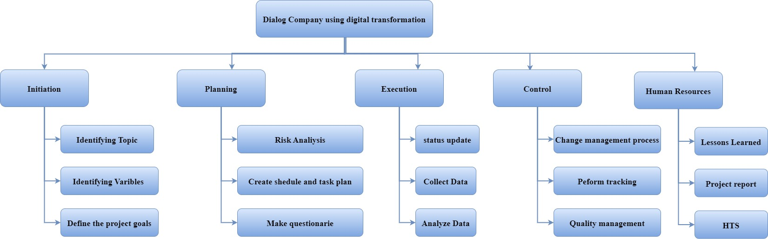

Figure 3 : Work Breakdown Structure of Dialog Company

# Gantt Chart of The Dialog Company Research

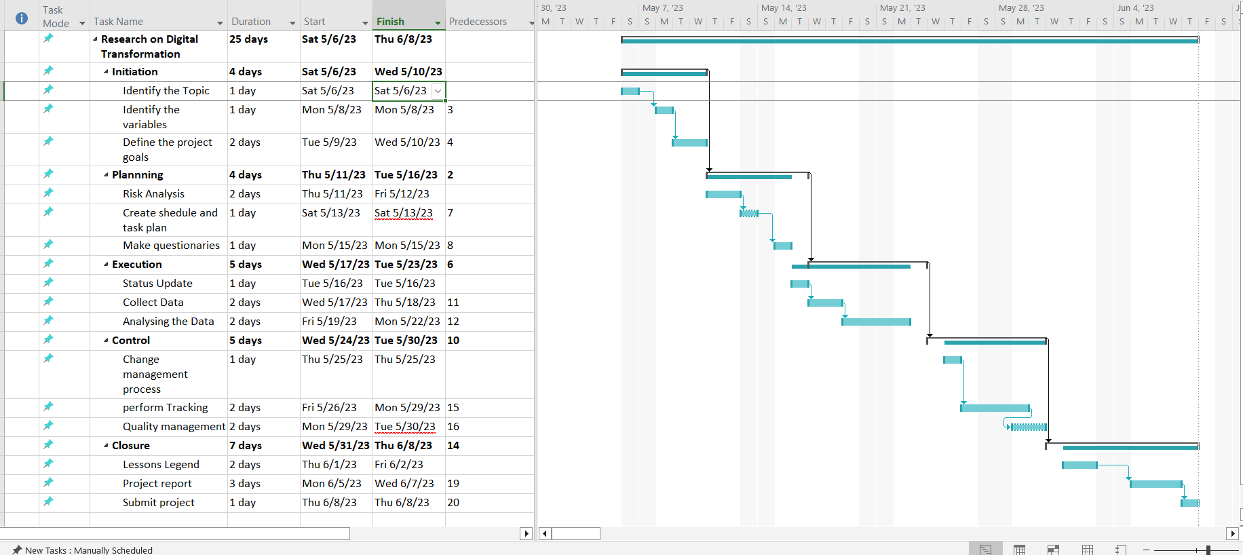

Figure 4 : Gantt Chart of The Dialog Company

# The Ethics

Ethics serve as the moral compass guiding individuals and organizations toward responsible, fair, and just behavior in their interactions and decision-making processes. In the realm of business, ethical considerations encompass a wide spectrum, including transparency, integrity, honesty, and respect for stakeholders' interests. Upholding ethical principles fosters trust, credibility, and sustainability within an organization and its relationships with customers, employees, communities, and the broader society.

In business practices, ethics dictate fair treatment of employees, ensuring their well-being, offering equal opportunities, and maintaining a safe work environment free from discrimination and harassment. Ethical conduct extends to customer relations, emphasizing honesty in marketing, providing quality products/services, and honoring commitments. Additionally, organizations are expected to operate ethically in their dealings with suppliers, partners, and competitors, avoiding unfair practices and maintaining transparency

Ethical behavior transcends legal obligations, aiming to do what is morally right, even when not explicitly mandated by laws or regulations. It involves making decisions that consider not only immediate gains but also long-term impacts on stakeholders and the environment. Ethical considerations also encompass environmental sustainability, social responsibility, and philanthropy, reflecting a commitment to contributing positively to society beyond profit-making motives.

Ultimately, ethical conduct in business establishes a foundation of trust and integrity, enhancing an organization's reputation, fostering stronger relationships, and contributing to long-term success. Adhering to ethical principles not only aligns with societal expectations but also serves as a guiding principle for responsible and sustainable business practices.

## Ethics that use for Digital Transformation

Privacy and Data Protection: Ensuring the privacy and security of user data is paramount. Organizations must handle data ethically, collecting only necessary information, obtaining explicit consent, and implementing robust security measures to protect against breaches or misuse.

Transparency and Accountability: Being transparent about how data is collected, processed, and used is crucial. Organizations should communicate clearly with users about data practices, algorithms, and the purpose behind technology implementations. Moreover, they should be accountable for the outcomes of their digital initiatives.

Fairness and Bias Mitigation: Algorithms and AI systems should be designed to avoid bias and discrimination. Mitigating biases in data and algorithms ensures fair treatment of individuals and prevents reinforcing existing societal biases.

Inclusivity and Accessibility: Ensuring digital tools, platforms, and services are accessible to all individuals, regardless of their abilities or backgrounds, fosters inclusivity. Designing user interfaces that accommodate diverse needs and providing equal access to technology is vital.

Responsible AI and Automation: Deploying AI and automation ethically involves ensuring that these technologies operate in line with ethical norms and human values. Ethical AI aims to benefit society while minimizing harm, respecting human autonomy, and enabling human oversight where necessary.

Sustainability: Considering the environmental impact of digital technologies is essential. Sustainable digital transformation involves reducing energy consumption, minimizing electronic waste, and adopting eco-friendly practices in technology deployment.

Continuous Learning and Adaptation: In an ever-evolving technological landscape, organizations must foster a culture of continuous learning and adaptability. This includes staying updated on ethical guidelines, addressing emerging ethical challenges, and adapting strategies accordingly.

## The Reasons using Ethics.

When it comes to how we behave in professional settings or when making significant decisions, ethics operate as the guiding principles that mold our actions and interactions with others as well as our behavior within society. It is crucial to include ethical considerations in paragraphs for a number of reasons:

Setting Standards and Values: Including ethics in paragraphs helps establish the ethical framework within which actions, decisions, and discussions take place. It sets a standard of behavior aligned with moral values, guiding individuals or organizations to make principled and responsible choices.

Building Trust and Credibility: Ethical considerations foster trust and credibility. When discussing topics or making arguments within paragraphs, incorporating ethical principles demonstrates integrity, reliability, and a commitment to doing what is right. This enhances the credibility of the information presented.

Addressing Societal Impact: Ethics in paragraphs help address the broader societal impact of actions or decisions. By considering the ethical implications of ideas or proposals, paragraphs contribute to discussions that contemplate the greater good, societal welfare, and the consequences of various courses of action.

Encouraging Critical Thinking: Ethical discussions within paragraphs encourage critical thinking. They prompt individuals to consider various perspectives, weigh ethical dilemmas, and evaluate the consequences of actions, fostering a deeper understanding of complex issues.

Responsible Communication: Including ethical considerations in paragraphs promotes responsible communication. It encourages respectful dialogue, openness to diverse viewpoints, and a focus on values that transcend personal biases or interests.

Guiding Decision-Making: Ethical paragraphs assist in decision-making processes. By laying out ethical arguments or considerations, they help individuals or organizations navigate ethical complexities, leading to more informed and conscientious decisions

## Advantages of Using Ethics

Guiding Principles: Ethics provide a moral compass, guiding individuals and organizations in making principled decisions aligned with values, integrity, and moral standards. They serve as a framework for determining right from wrong, facilitating responsible behavior and actions.

Building Trust and Relationships: Adhering to ethical principles fosters trust and credibility in personal and professional relationships. Individuals or organizations that consistently demonstrate ethical behavior and integrity tend to earn respect and trust from others, fostering stronger and more meaningful relationships.

Enhanced Decision-Making: Ethical considerations facilitate better decision-making. When faced with complex choices or ethical dilemmas, ethical guidelines help individuals evaluate options based on moral principles, societal impact, and long-term consequences, leading to more thoughtful and responsible decisions.

Positive Reputation and Image: Embracing ethics contributes to a positive reputation and image. Individuals and organizations known for ethical conduct are perceived as reliable, trustworthy, and socially responsible, which can enhance their standing within communities, industries, or society at large.

Promoting Fairness and Equality: Ethics promote fairness and equality. Ethical principles advocate for treating individuals impartially, respecting diversity, and upholding human rights, fostering an environment that values justice and equal opportunities for all.

Strengthening Societal Values: Embracing ethics contributes to the reinforcement of societal values. By adhering to ethical norms, individuals and organizations set examples and influence others to prioritize values that benefit society, such as honesty, respect, fairness, and compassion.

Mitigating Risks and Conflicts: Ethical conduct helps prevent conflicts and mitigate risks. Anticipating ethical implications in decision-making processes can prevent potential legal, financial, or reputational risks, reducing the likelihood of conflicts arising from unethical behavior.

Contributing to Personal Growth: Practicing ethics fosters personal growth and self-awareness. Engaging in ethical reflection and ethical behavior enables individuals to develop a stronger sense of character, integrity, and moral reasoning, contributing to their personal development.

# Analyzing data of digital transformation in Dialog Company

This section provides a justification of the results that are achieved after applying the statistical procedures to the collected data. A thorough analysis and discussion are conducted about the data gathered via the questionnaire.

## Introduction

While the testing of gathered data and comparison with theories discussed in this chapter is straightforward, the process of doing so is not simple. Employee loyalty and commitment are complicated topics that need to be investigated and compared to current beliefs. It is also much harder to test these problems in real-world situations.

Data collection started with all Dialog Axiata PLC workers receiving surveys via email. The topic of discussion was highly sensitive to the company and the employee, therefore distributing the questionnaire to each person and gathering their responses separately had an effect on their thoughts.

Following completion of data collection, the data was entered into a Microsoft Excel sheet created to generate the aggregate data results for simple statistical analysis. The data was ready for analysis with Microsoft Excel and SPSS software after the preparatory step was finished.

## Demographical data analysis

Demographic data analysis serves as a powerful lens through which societies, businesses, and policymakers gain insights into the intricate fabric of populations. This method involves scrutinizing and interpreting statistical information encompassing diverse characteristics like age, gender, income, education, and more. This analysis allows for a deeper understanding of societal shifts, aiding in the anticipation of evolving trends, population dynamics, and shifts in preferences. For businesses, this analysis paves the way for targeted marketing strategies, enabling precise tailoring of products and services to suit specific consumer groups. Moreover, governments leverage demographic insights to frame policies that cater to the varying needs of different segments, be it healthcare provisions, urban development, or educational reforms. Ultimately, demographic analysis stands as a cornerstone for informed decision-making, fostering a more responsive and inclusive approach in both public and private sectors.

## Gender Distribution

The selected research site states that the material given suggests that Dialogue Axiata PLC values the contributions of both men and women.

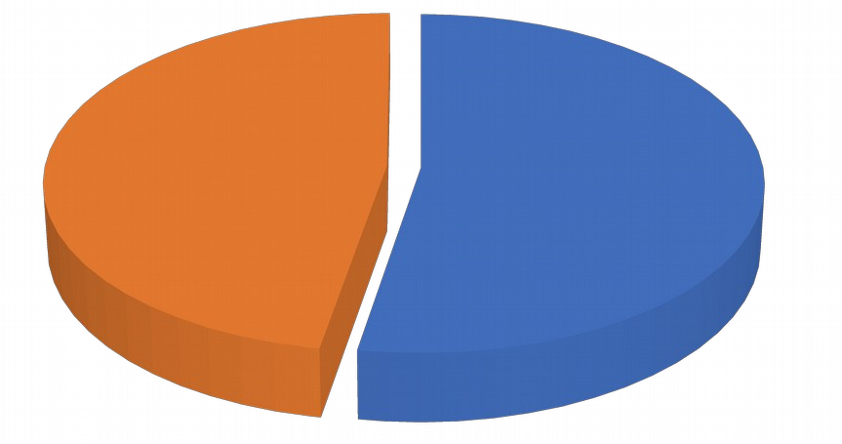

**male; 52.70%**

**female; 47.30%**

**gender**

Figure 5 : Gender Distribution

## Age Group

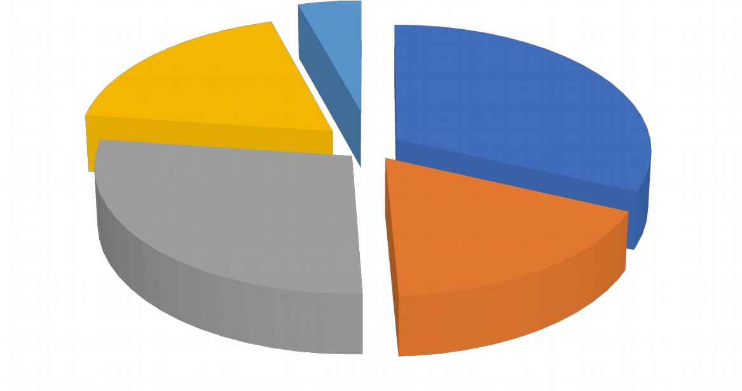

**18-30**

**; 31.70%**

**31-40**

**; 17.60%**

**41-50**

**; 27.80%**

**51-60**

**; 18.50%**

**Above 60; 4.40%**

**age**

Figure 6 : Age Group

Just 4% of Dialog Axiata PLC's staff, a private company are over 60 years old (Refer figure). This indicates that the company's workforce is comparatively youthful.

As a result, 32% of all participants are in the age category of 18 to 30 years, which comprises the bulk of respondents (18%), while the age group of 31 to 40 years comprises 18% of all participants. Because of this, 50% of the institution's workforce is young, which is encouraging given each person's high level of energy.

## Civil Status

The sample's makeup broken down by marital status level is displayed. Of those surveyed, 45% are married. 55% of responders are employees who are single

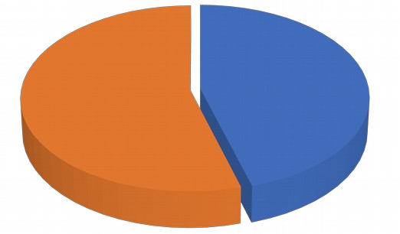

**married;**

**45.50%**

**unmarried.**

**54.50 %**

**Civil Status**

Figure 7 : Civil Status

## whether employees read the above survey description and knew or did not know what this research was about.

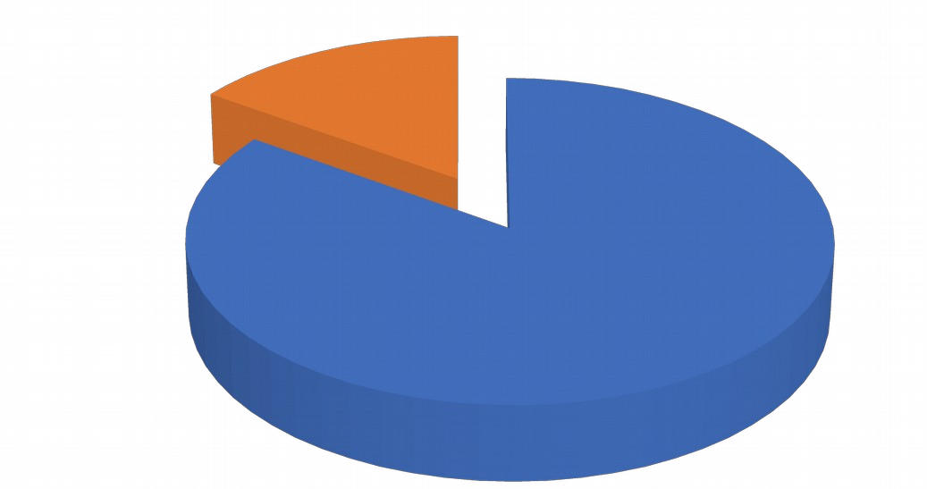

**Yes; 84.73%**

**No; 15.27%**

Yes

No

Figure 8 : whether employees read the above survey description and knew or did not know what this research was about.

Upon reviewing the survey description above, it is evident how many employees were unaware of the purpose of the study. Fifty-five percent of the employees who answered the questionnaire had a thorough comprehension of the research, whereas just fifteen percent did not know anything about it. This is typical. Since such

Since no two employees in a business have the same rank or degree of knowledge, it can be challenging to grasp everything.

## Interference Analysis

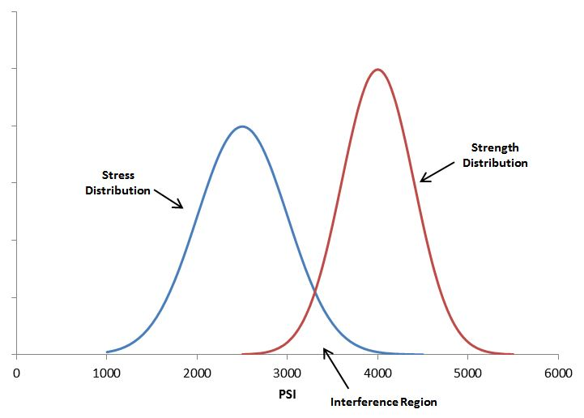

Figure 9 : Interference Analysis

The process of inferring characteristics of a probability distribution through data analysis is known as statistical inference. By producing estimates and evaluating hypotheses, for instance, inferential statistical analysis infers population features. It is believed that the observed data set is a sample of a bigger population.

## Descriptive Statistics

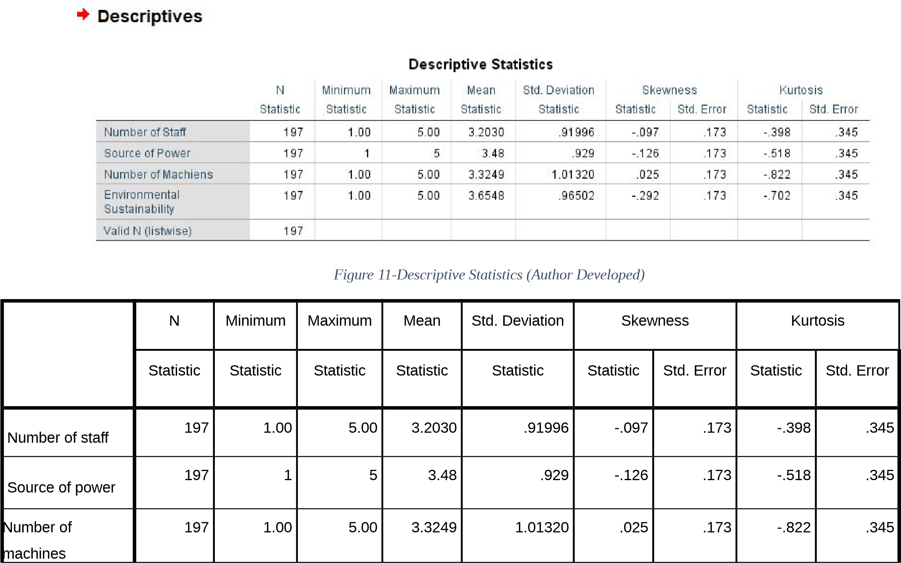

Figure 10 : Descriptive Statistics

A descriptive statistic uses the sample size and unique qualities of each variable to summarize the data set and provide context. The dependent variable and all of the independent factors are shown in detail in Table 1. The mean answer provided by participants in the sample population is indicated in Table 02 as the Mean. When the number of employees in the institution is taken into account, the mean is 3.2. In other words, they responded to the inquiries about the institution's staff count in an impartial manner.

The average is 3.3 when taking into account the institution's power supply and 3.4 when taking into account the quantity of computers that are available. It has a reasonable demeanor when responding.Table 02 illustrates how symmetrically distributed the variables "number of staff," "number of machines," and "source of power system" are, with a range of -1.0 to 1.0. The number of machines variable exhibits a positive symmetric skewness.

Every variable displays a negative distribution in terms of kurtosis. Negative values are also displayed by dependent variables.

## Reliability Testing of Data set

A thorough analysis is conducted as part of a dataset's reliability testing process to guarantee the dependability, precision, and consistency of the data it includes. This procedure entails a number of steps, including examining the methods used to collect the data, cleaning and preprocessing the data to remove errors and inconsistencies, performing statistical analyses to comprehend the properties of the dataset, evaluating internal consistency using methods such as Cronbach's alpha, and verifying the dataset's dependability by validating it against other sources. Furthermore, if appropriate, tests for test-retest reliability (which verifies consistency over time) and inter-rater reliability (which assesses agreement between several raters) may be carried out. The dataset's robustness and reliability for its intended application in analysis, modeling, or decision-making must be guaranteed as the final objective.

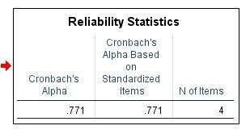

Figure 11 : Reliability Statistics

## Nature of Dependent Variable

The nature of a dependent variable in a dataset refers to its fundamental characteristics and how it behaves within the context of a study or analysis. The normality distribution statistic for the dependent variable of environmental sustainability in this investigation, as determined by SPSS, is shown in graph 01 of the study.

The generally bell-shaped curve displayed by the histogram with a mean value of 3.65 suggests that the dependent variable in this study is roughly normally distributed.

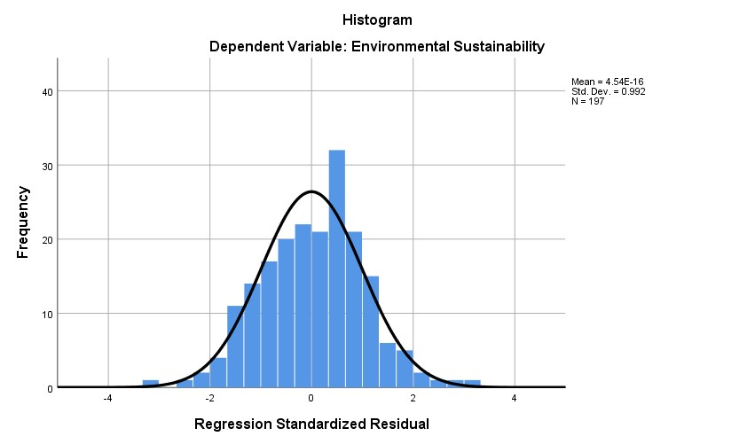

Figure 12 : Normality distribution statistics calculated by SPSS for the dependent variable of environmental Sustainability

Additionally, the descriptive statistics for the dependent variable of environmental sustainability are shown in the following figure. The ranges for the Kurtosis and Skewness values are, respectively, -.702 to 0.345 and -.292 to 0.173. These values fall between -1 and 1, indicating that the dependent variable has a roughly normal distribution.

## Research

Research is a systematic and methodical inquiry undertaken to expand knowledge, solve problems, or explore phenomena. It involves a structured process of investigation, analysis, and interpretation aimed at gaining a deeper understanding of a subject or addressing specific questions. Through research, individuals seek to explore new ideas, test hypotheses, or validate existing theories by collecting and analyzing data using various methodologies and tools. Whether in academia, business, science, or other fields, research serves as a foundation for informed decision-making, innovation, and advancements in knowledge. It often involves critical thinking, rigorous analysis, and the application of specific methodologies to acquire reliable and credible information, ultimately contributing to the expansion of understanding and the development of solutions to complex issues.

In the context of a business's study on digital transformation, there are various reasons to support the use of both qualitative and quantitative research methods.

## Qualitative research Methods

**Interviews/Focus Groups**

Conducting interviews or focus groups with employees, customers, or stakeholders can provide rich insights into their experiences, perceptions, and challenges related to the digital transformation. These discussions can reveal nuanced information about user needs, preferences, and pain points that quantitative data might not capture comprehensively. For instance, dialogues with employees about the impact of new digital tools on workflow efficiency or customer feedback on user experience can unveil valuable qualitative insights.

There are two ways that are ,

1. Online Surveys

Online surveys are structured questionnaires administered through digital platforms, gathering information from respondents on various topics or research objectives. They offer a convenient and efficient method to collect data from a wide audience

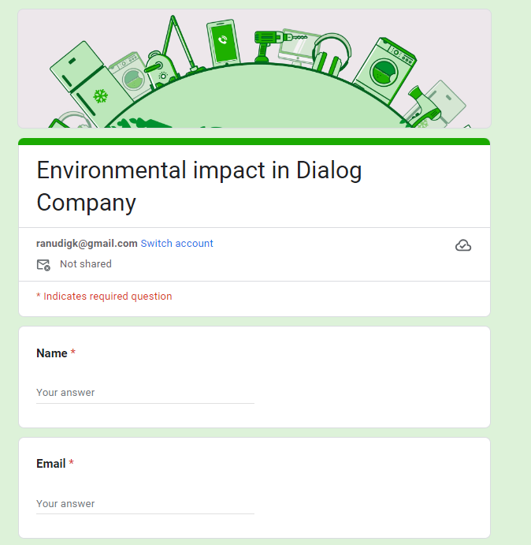

Figure 13 : Author Developed Suvey

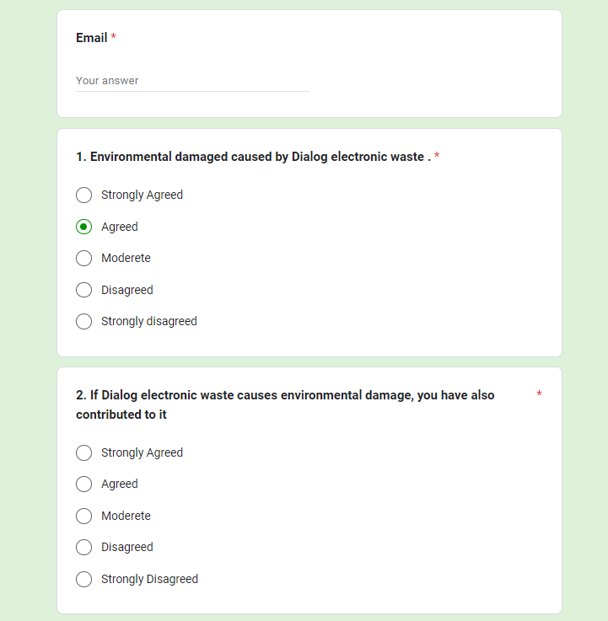

Figure 14 : Author Developed Survey

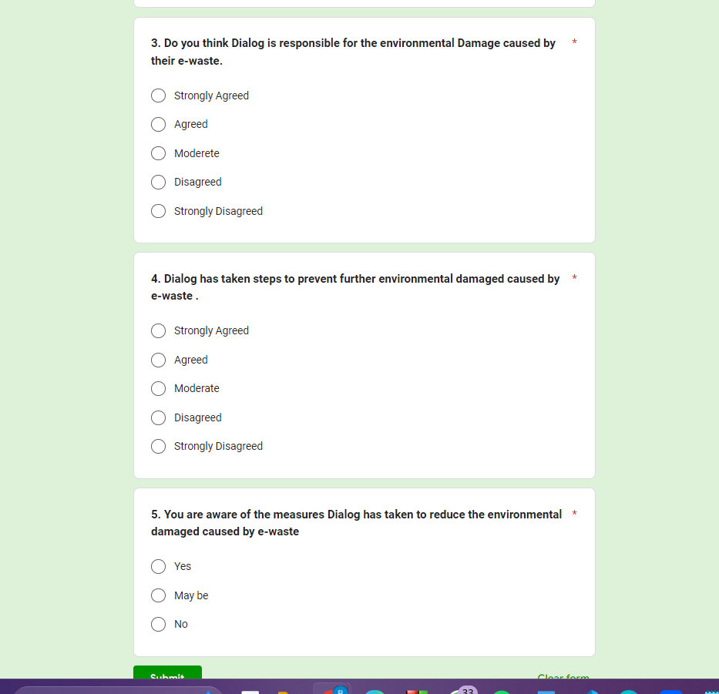

Figure 15 : Author Developed Survey

**Observation/Case Studies**

Observing employees using new digital platforms or conducting case studies on successful digital transformation projects within the company can offer detailed contextual information. This qualitative approach can uncover best practices, obstacles faced, and success stories that provide valuable guidance for the transformation process.

## Quantitative Methods:

Surveys/Statistical Analysis: Deploying surveys or collecting quantitative data on user adoption rates, system performance metrics, or customer satisfaction scores related to digital products/services aids in quantifying the impact of the transformation. Analyzing numerical data through statistical methods allows for trend identification, correlation assessments, and objective measurements of the transformation's effectiveness. For example, analyzing survey responses on user satisfaction post-implementation of new digital tools can provide quantitative metrics on improvements.

Data Mining/Quantitative Content Analysis: Utilizing data mining techniques on digital usage patterns, website analytics, or social media engagement metrics provides quantitative insights. These analyses help in understanding user behavior, preferences, and trends, offering concrete data-driven information to guide decision-making during the transformation journey.

## Project Management plan for the Project

|  |  |  |
| --- | --- | --- |
| **Project Management Plan**: Environmental Impact of Digital Transformation at Dialog Company | | |
| **Project Components** | **Timeline** | **Responsibilities** |
| Project Initiation | 1 week | Define project scope, objectives, and constraints. Formulate a project team and assign roles. Draft project management plan. |
| Research and Data Collection | 4 weeks | Conduct literature review. Gather primary data through surveys, interviews, and data collection. Analyze collected data. |
| Environmental Impact Assessment | 3 weeks | Evaluate and quantify environmental impact. Identify significant contributors to environmental damage. |
| Recommendation Development | 2 weeks | Develop actionable recommendations to minimize environmental damage. Prioritize recommendations. |
| Project Implementation Plan | 1 week | Develop structured plan for recommendation implementation. Allocate resources and define timelines. |
| xecution and Monitoring | 6 weeks | Implement strategies to reduce environmental impact. Monitor progress, address challenges, and make adjustments. |
| Reporting and Documentation | 2 weeks | Prepare comprehensive reports summarizing findings, recommendations, and outcomes. Present findings to stakeholders. |
| **Key Deliverables** | | |
| - Environmental impact assessment report.  - Data analysis reports.  - Actionable recommendations document.  - Project management plan and progress reports. | | |
| **Assumptions and Constraints** | | |
| - Data Accessibility.  - Limited access to comprehensive life cycle data of digital devices.  - Resource Limitations.  - Rapid technological advancements.  - Regulatory Changes.  - Data accuracy and reliability.  - Stakeholder cooperation.  - Comprehensive understanding of technology lifecycle. | | |

Table 2 : Project Management Plan

## The Way use the Project management plan to the project

The project management plan played a pivotal role at every stage of the environmental impact assessment of digital transformation at Dialog Company. In the initiation phase, it served as a blueprint, defining the project's scope, objectives, and constraints. It outlined the roles and responsibilities of each team member, ensuring clarity in the project's direction and accountability. This initial roadmap set the tone for the entire project, aligning the team with a unified vision and purpose.

During the research and data collection phase, the plan guided the systematic approach to gathering information. It delineated the strategies for conducting literature reviews, surveys, interviews, and data analysis, ensuring that all necessary data points were considered. By following the predefined timelines and methodologies outlined in the plan, the team ensured consistency and thoroughness in data collection, contributing to the project's reliability and validity.

As the environmental impact assessment progressed, the project management plan facilitated the assessment's structure. It guided the evaluation and quantification of environmental impacts caused by digital devices, providing a framework for the identification of key contributors to environmental damage. This structured approach allowed for a comprehensive analysis aligned with the plan's objectives, enabling the team to derive meaningful insights from the data collected.

Furthermore, the plan played a critical role in the formulation of recommendations. It guided the development of actionable strategies aimed at minimizing environmental harm caused by digital devices. The project management plan's timelines and allocated resources ensured that these recommendations were feasible, prioritized, and aligned with the project's overall goals.

Throughout the project's execution and monitoring phases, the plan served as a reference point for progress tracking and adaptation. It facilitated the implementation of strategies to reduce environmental impact, providing a structured approach for monitoring progress, addressing challenges, and making necessary adjustments. This continuous referencing of the plan ensured that the project remained on track, adhering to timelines and objectives.

Finally, in the reporting and documentation phase, the project management plan guided the preparation of comprehensive reports summarizing findings, recommendations, and outcomes. It ensured that the final deliverables were aligned with the initially defined scope and objectives, providing stakeholders with a clear understanding of the project's achievements and implications. Overall, the project management plan acted as a guiding compass, steering the project toward its successful completion and ensuring that every stage was conducted systematically and purposefully.

## Gantt Chart of the Assignment

# References

Sadeera, N., n.d. *Medium.* [Online]   
Available at: https://nevsadee.medium.com/

Nitte School of Fashion Technology. 2021. What is AI system that automatically shows people

whether or not their suit fits. |Imperva. [ONLINE] Available at:

https://www.imperva.com/learn/applicationsecurity/ IOT-assessment.

Checkpoint Roles. 2021. What Is a Company main interest secondary security system with AI? |

Checkpoint Roles. [ONLINE] Available at: https://www.thinkwithgoogle.com/.

Cleverism. 2021. Management Information Systems (MIS): Definition and How It Works |

Cleverism. [ONLINE] Available at: https://www.cleverism.com/management-informationsystems-mis.

Research-Methodology. 2021. Questionnaires . [ONLINE] Available at: https://researchmethodology.net/

research-methods /survey-method/questionnaires-2.

###### Grading Rubric

|  |  |  |
| --- | --- | --- |
| **Grading Criteria** | **Achieved** | **Feedback** |
| **LO1 Establish project aims, objectives and timeframes based on the chosen theme** |  |  |
| **P1** Devise project aims and objectives for a chosen scenario. |  |  |
| **P2** Produce a project management plan that covers aspects of cost, scope, time, quality, communication, risk and resources. |  |  |
| **P3** Produce a work breakdown structure and a Gantt Chart to provide timeframes and stages for completion. |  |  |
| **M1** Produce a comprehensive project management plan, milestone schedule and project schedule for monitoring and completing the aims and objectives of the project. |  |  |
| **LO2** Conduct small-scale research, information gathering and data collection to generate knowledge to support the project |  |  |
| **P4** Carry out small-scale research by applying qualitative and  quantitative research methods appropriate for meeting project aims and objectives. |  |  |
| **M2** Evaluate the accuracy and reliability of different research methods applied. |  |  |

|  |  |  |
| --- | --- | --- |
| D1 Critically evaluate the project management process and appropriate research methodologies applied. |  |  |
| **LO3** Present the project and communicate appropriate recommendations based on meaningful conclusions drawn from the evidence findings and/or analysis |  |  |
| P5 Analyse research and data using appropriate tools and techniques. |  |  |
| P6 Communicate appropriate recommendations as a  result of research and data analysis to draw valid and meaningful conclusions. |  |  |
| M3 Evaluate the selection of appropriate tools and techniques for accuracy and authenticity to support and justify recommendations. |  |  |
| **D2** Critically evaluate the research and data analysis tools used in the project development stages.. |  |  |
| **LO4** Reflect on the value gained from conducting the project and its usefulness to support sustainable organisational performance |  |  |
| **P7** Reflect on the value of undertaking the research to meet stated objectives and own learning and performance. |  | . |
| **M4** Evaluate the value of the project management process and use of quality research to meet stated objectives and support own learning and performance. |  |  |
| **D3** Critically evaluate how the project supports sustainable organisational performance. |  |  |